There are good reasons for killing mosquitoes. These pesky little blood sucking vampires can ruin a picnic or any outdoor activity. Mosquitoes can become infected with the Zika virus and transmit this virus to humans. The risk to pregnant women of becoming infected with Zika is sobering (1). So, it is no wonder that mosquito treatment companies have become one of the fastest growing franchises in the US. These companies show up in spiffy new trucks and get homeowners to sign service contracts for periodic visits. Then they fog yards with clouds of mosquito-killing insecticide.

How to Control Mosquitoes Without Killing
Honey Bees and Other Beneficial Insects

Tom Rearick, UGA Master Beekeeper
Insecticide fogs have several problems. First, fogs do not respect property lines and they rarely stay in one place. I am a beekeeper and I have lost multiple bee hives in a single day due to insecticide drift. That experience was not only expensive, but it was heartbreaking. Imagine coming home to find all your pets or livestock dead. Second, insecticide kills all insects and there are good reasons for not wanting to kill every flying or crawling insect out there. Most insects are beneficial or at least benign. In addition to honey bees, lots of other insects provide pollination. Insects create fertile soil, provide food for birds and other wildlife, and prey on unwelcome insects - like mosquitoes - to keep them in check. Long-lasting insecticides, like the pyrethroid compounds used to fog mosquitoes, wash into streams and kill beneficial aquatic life necessary to sustain trout and other valuable game fish.
Sadly, information on ways to kill mosquitoes without also harming beneficial insects is hard to find. It seems that killing the good insects with the bad is an inconvenient truth that some insect control service providers either gloss over or redirect ("Our insecticide is natural…it is based on chrysanthemums" - when was the last time you found a pile of dead insects under a bed of blooming mums?). If you want to learn how you can control mosquito populations more effectively without sacrificing honey bees and other beneficial insects, read on. We will arm ourselves with information about how the mosquito lives and then use that knowledge to wage war against mosquitoes with little or no collateral damage to other beneficial insects.
Here is the minimum you need to know about mosquitoes in order to design strategies to keep them from biting you:
- Mosquitoes are attracted to dark, humid areas in which to lay their eggs in water. These eggs turn into worm-like larvae which turn into pupa (like butterflies) and finally emerge as adult mosquitoes from the surface of the water. If you remove the water necessary to grow in, you get rid of mosquitoes.
- Mosquitoes are weak fliers. As a result, they tend not to travel long distances and rest on low-lying plants, tall grasses and shrub that provides some protection from the wind and rain. If you spray anything, it should be these plants (if they are not flowering).
- Mosquitoes hunt their prey (you) by sensing carbon dioxide and visual recognition but they prefer some human targets over others based on smell. Learn not to smell like their preferred target.

Stop mosquitoes before they can fly or bite
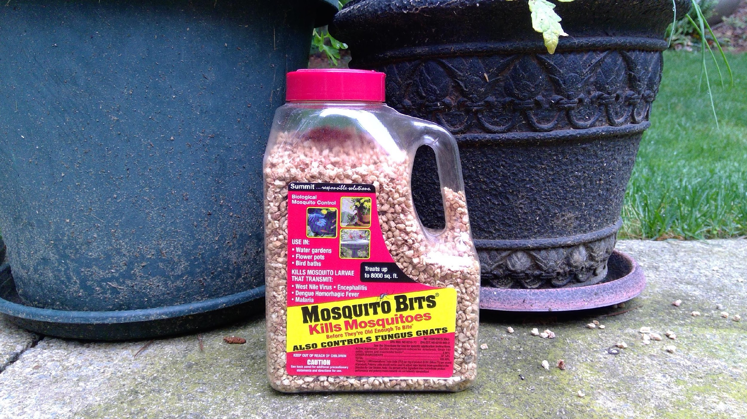
Most mosquitoes lay their eggs in small, stagnant pools of water. The first thing you should do to rid yourself of mosquitoes is to reduce as many sources of stagnant water as possible. If you have gutters, get them cleaned because water retained by dams of wet leaves is a perfect source of stagnant water. Toys in the yard, old tires, leaky outdoor faucets, low spots in a yard where rainwater pools, and saucers under potted plants all harbor mosquito larvae. Since mosquitoes are weak fliers, most of your mosquitoes will hatch within 100 yards of your location. Get rid of stagnant water close to you and you will get rid of most mosquitoes.
If you cannot remove a source of stagnant water, you can still make it deadly to mosquitoes without being deadly to honey bees and other beneficial insects. If you have a small pond, add fish that feed on mosquito larvae. Gambusia or 'Mosquito Fish' can be purchased and added to a pond to eat mosquito larvae. If you have a bird bath or regularly watered potted plants on saucers, add Bacillus thuringiensis subspecies israelensis or BTi to the water. This is a bacterium that kills mosquito larvae but is harmless to adult insects. I add it to the water source that I provide in the summer for my honey bees. They gather the same water that kills any larvae that hatch from mosquito eggs. A convenient source of Bti is a product called 'Mosquito Bits' available at Home DepotTM, LowesTM, and other garden centers. It consists of dried corn kernel pieces infused with Bti which you simply sprinkle into stagnant water or on depressions on the ground that hold rainwater.
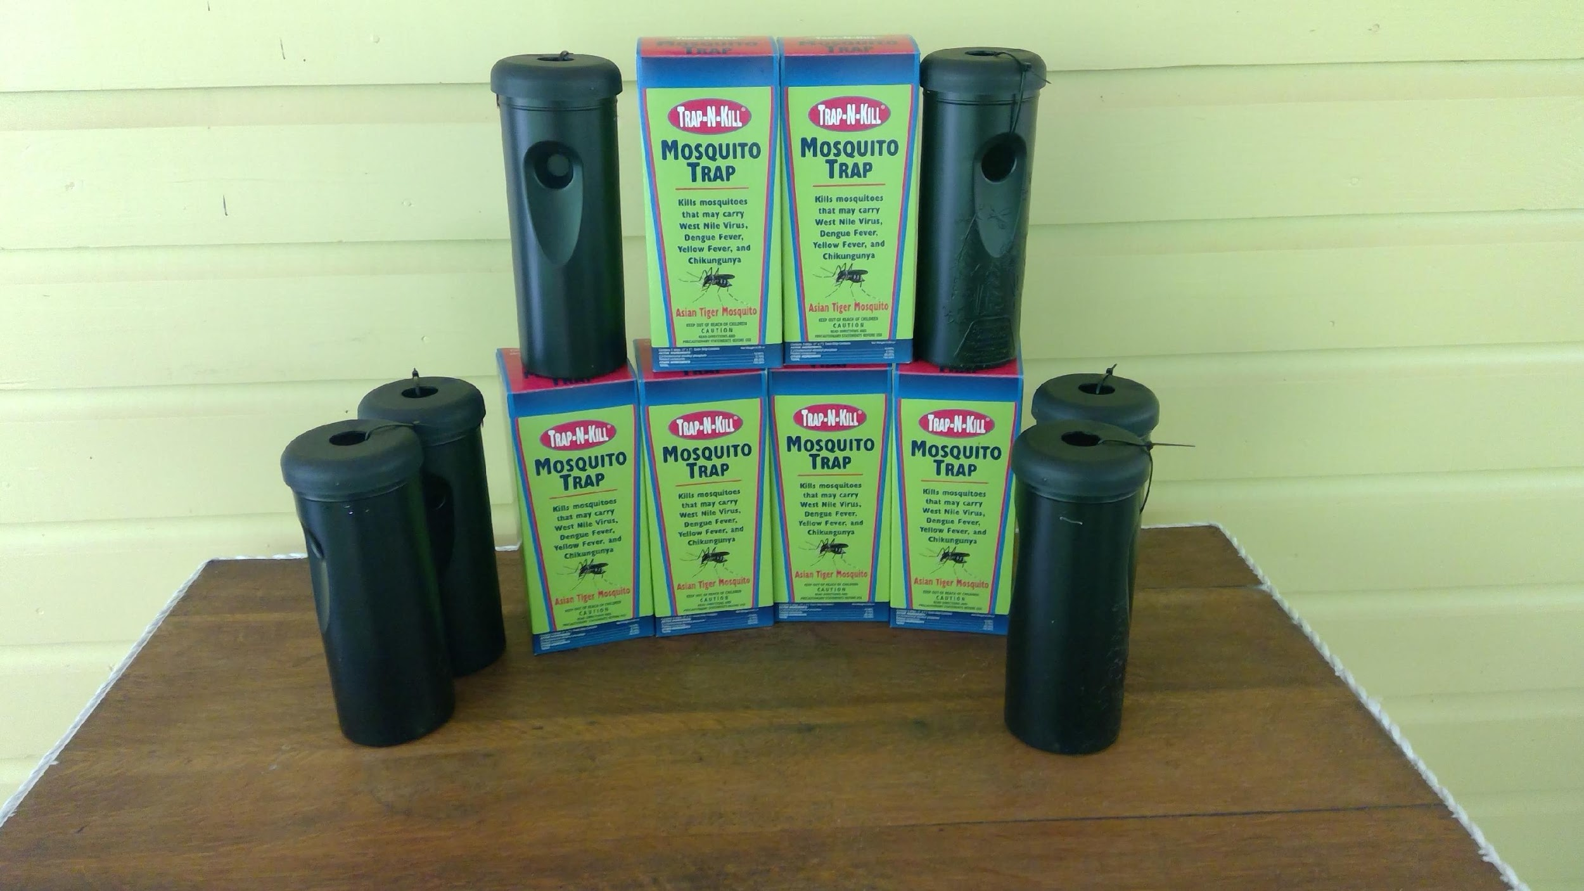
Another way to prevent larvae from hatching is to provide traps that attract mosquitoes to lay eggs but prevent those eggs from ever escaping as grown adults. These are called ovitraps. Studies have shown that population densities can be reduced with sufficiently large numbers of maintained traps. You have two options: buy 'em or build 'em. Links to each are given below. I use the Trap-n-kill ovitrap shown below.

Let nature work for you
You need not be alone in your pursuit of ridding your yard of mosquitoes. Nature can help you if you make your yard attractive enough to natural mosquito predators. In addition to mosquito eating fish, there are beneficial insects and bats that love nothing more than to eat mosquitoes.
When you fog indiscriminately, you kill one of the best mosquito hunters in the insect world: Dragonflies. Besides, it is great fun to watch dragonflies who catch mosquitoes and small flies as they swoop around your yard!
At dusk, I can look up in the sky and watch brown bats catching mosquitoes. A pregnant brown bat can eat her weight in insects every night! That is a lot of mosquitoes. If you cannot see bats flying at night, perhaps you can make your yard more attractive to bats by putting up a bat box.

If you must spray, know how to spray responsibly
If you intend to spray for mosquitoes, you should at least understand the difference between techniques that result in non-selective killing of every living insect and techniques that minimizes exposure to beneficial insects.
First of all, insecticides kill insects. Honey bees, dragonflies, butterflies, and other beneficial pollinators are insects. An insecticide does not exist that discriminates between undesirable and desirable insects. Don't let anyone tell you anything different. 'Spraying responsibly' means knowing when, where, and how to spray in order to reduce exposure of beneficial insects to insecticide.
Never spray flowers in bloom and do not spray between sunrise and sunset. Honey bees and other pollinators are most active during the day then visiting flowers for nectar and pollen. Honey bees are ill suited to nighttime flight. So, it is then logical to spray, if you must, when these beneficial insects are not flying.
Use a large droplet sprayer (not a fogger) to spray ground-hugging foliage, tall grass, shrubbery. This is where mosquitoes seek shelter from wind and rain. These are not areas that interest honey bees unless the plants are in bloom. Better yet, remove high grasses and weeds. Kudzu and ground ivy are hard-to-treat plants that harbor mosquitoes on the underside of their leaves. It is best to rip them out.
Do you live near a beekeeper? If so, you should notify that beekeeper that you intend to spray because there are things that beekeepers can do to reduce the potential for damage to their honey bee colonies.
This topic is covered in more detail on the Metro Atlanta Beekeepers Association website (see link below)

If you are going to hire a professional to spray, know what to ask

When Do You Spray?
Insecticide should be sprayed when honey bees are not foraging – before sunrise and after sunset – and then only when flowers are not in bloom. Mosquito control companies are reluctant to honor this request because they work 9-5. However, according to the American Mosquito Control Association (AMCA), an industry trade association:

“It is also the policy of the AMCA that applicators strictly conform to restrictions posted on product labels as a matter of both federal law and environmental stewardship. Product labels often contain specific language such as “do not apply when flowers are in bloom…” regarding application methods that minimize pollinator exposure. This is the law and it must be complied with.” (https://www.mosquito.org/page/pollinators )

Some mosquito control companies love to sign contracts that pay for recurring prophylactic applications. However prophylactic applications waste money and may contribute to undesirable insects becoming resistant to pesticide. It is much better to apply insecticide only when it is absolutely needed. The AMCA recommends an integrated pest management approach which includes monitoring of mosquito populations:

Effective mosquito control requires continual survey of adult mosquito densities to determine if certain triggers for control are met. This reduces the use of adulticides to only those times when they are required. (https://www.mosquito.org/page/FAQ)

What Do You Spray?
Many commercial mosquito control services boast about their 'natural' insecticide called Permethrin. This pesticide, similar in structure to chemicals found in Chrysanthemums, is as deadly to honey bees, beneficial insects, and aquatic life as other less 'natural' pesticides. Permethrin that washes into ground water is highly toxic to fish and organisms that live in fresh and saltwater. It has been found to persist in river sediment for more than a year.

How Do You Spray?
On this topic, my advice diverges from that of the AMCA. The AMCA hails Ultra Low Volume (ULV) spray applicators or foggers as a safer means of applying minimal amounts of pesticide to a large space. However, the fog produced by ULV sprayers consists of tiny droplets of insecticide that float in the air and can travel off property with disastrous results. If you must spray, please use a large droplet sprayer like the pump sprayer one gets at a garden center. The larger droplets do not drift making their application much more targeted to specific foliage. These sprayers are also call spot or sled sprayers.

I am a gardener and I don't spray for mosquitoes so I should be ok, right?
Maybe. Maybe not.
Avoid insecticide powders like SevinTM dust. When honey bees fly, they accumulate a positive charge that makes pollen stick to them. A positive charge also attracts insecticidal powders which then get carried back to the colony and mixed in with the pollen that is later fed to honey bee brood.
Apply herbicides (such as RoundupTM) and fungicides as you would pesticides – only as a last resort and then only selectively – because they are also harmful to honey bees and probably harmful to beneficial insects as well. Recent research has found that a honey bee's immune system depends on a healthy gut microbiome. This is a fancy way of saying that the honey bee has beneficial fungus and bacteria in its gut that provides an immune response to toxins and disease. When honey bees are exposed to herbicides or fungicides, their beneficial gut flora can die and reduce the bee's ability to fight disease, pests, and toxins. In this way, herbicides and fungicides can transform an otherwise sublethal exposure to pesticides into a lethal one.

Learn to Coexist with Mosquitoes
Even if you nuke every living thing in your yard (which I seriously hope you will not), you will still encounter a few mosquitoes from up-wind and you will certainly encounter mosquitoes when you visit places where mosquito populations are uncontrolled. It is useful to know how to avoid mosquito bites wherever you go.
Some people seem to attract mosquitoes more than other people. This is because a significant part of the mosquito’s sense of smell is devoted to finding blood sources. Of 72 types of odor receptors on its antennae, at least 27 are tuned to detect chemicals found in perspiration. So, take a shower before entering a mosquito rich environment and use a repellent.
Mosquito repellents work. A few effective repellents recommended by the Centers for Disease Control include:
- DEET,
- picaridin,
- eucalyptus oil (OEO),
- Para-menthane-diol (PMD),
- 2-undecanone,
- ethyl butylacetylaminopropionate (IR3535).
Follow the directions for each carefully for best effect. Don't waste your money on acoustic or sonic repellents. Multiple independent studies have been unable to show any effectiveness.
Consider a screened-in porch or screen doors. Make sure that existing screens do not contain holes that allow mosquitoes in.
Wear long pants and long sleeve shirts when you venture to an outdoor venue that could have mosquitoes. Your clothing does not have to be heavyweight in hot weather. The U.S. military has been using permethrin-treated uniforms since the early 1990s. You can do the same thing by soaking your own clothes in a special Permethrin chemical treatment. It lasts several washings and kills mosquitoes, mites, and ticks on contact. But it needs to be applied correctly in order to be safe. Check the links given below.

Finally, recall that mosquitoes are weak fliers that avoid windy places. Sit under a fan and mosquitoes will stay away. If you are sitting at a picnic or other table, position a fan to blow under the table so your legs or ankles do not get bit up.

Enlist the assistance of your neighbors
You might do everything right but still have a mosquito control problem if your neighbor’s yard is a breeding ground. Share this document with your neighbors and agree to work together to control mosquito populations while also protecting beneficial insects. Like vaccination, you will have better outcomes if everyone participates.

Learn more
You are off to a good start learning to control mosquitoes without also harming beneficial insects. The following links are good places to learn more.
- Centers for Disease Control:
  - https://www.cdc.gov/features/stopmosquitoes/index.html
  - https://www.cdc.gov/westnile/vectorcontrol/integrated_mosquito_management.html
- Metro Atlanta Beekeepers Association, advice to beekeepers on how to survive or respond to pesticide bee kills: http://www.metroatlantabeekeepers.org
- Lethal Ovitrap:
  - https://en.wikipedia.org/wiki/Lethal_ovitrap
  - https://phc.amedd.army.mil/PHC%20Resource%20Library/MosquitoTrap-N-KillLethalOvitrap_FS_18-083-0915.pdf
  - Search for "trap-n-kill"
- Do-It-Yourself Ovitrap: https://www.instructables.com/id/Mosquito-Killing-Ovitrap/
- Summit Mosquito Bits (Bti): Search "summit mosquito bits"
- Permethrin clothing treatment:
  - https://www.consumerreports.org/insect-repellents/permethrin-treated-clothing-mosquito-bites/
  - https://sectionhiker.com/permethrin-soak-method-guide/

The author wishes to thank Julia Mahood and Linda Tilman, both UGA Master beekeepers for their comments on earlier drafts of this document. The author exonerates them from any errors that remain. To contact the author with corrections or comments, email him at tom.rearick@gmail.com.
This work is licensed under a Creative Commons Attribution 4.0 International License.
You may download electronic copies of this article at http://www.beehacker.com/wp/?p=1282.

